Face Mask Detection Training program / model creation flow

1. **Check if the following mandatory files available before execute of the script.**

* Dataset (contains sub-folder with two classes “with_Mask” and “without_Mask” contains images
* Training program file (from this will save best model and then go for application of the model)

1. 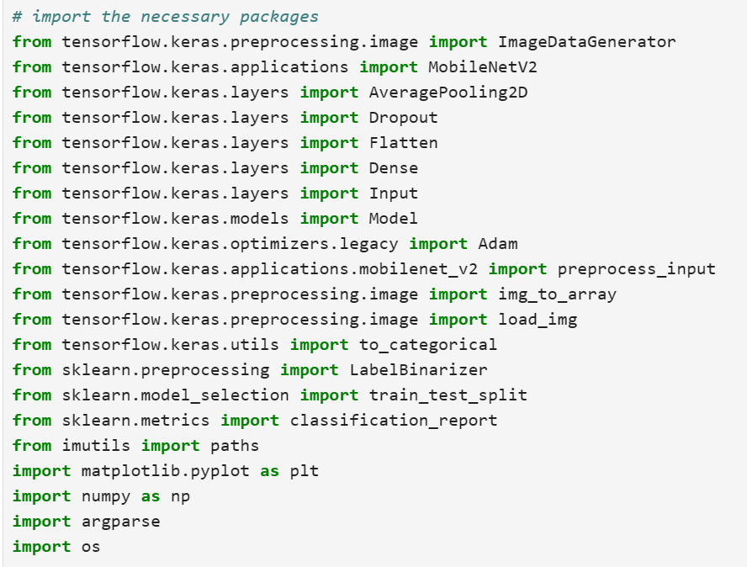**Load the necessary libraries and below is snippet of those.**

1. Here we are using argument parser for the script to be written in command-line console.

* Argument parser (ap) adding the argument (“--dataset”) which directs path to input dataset (which has two sub-folders “with_mask and “without_mask”) will be accessed at the time of running the script while running the entire program.
* Argument parser (ap) adding the argument (“--plot”) default output file name “plot.png” and help text let the user know it used to output plot file.
* Argument parser (ap) adding the argument (“--model”) default output model file name “mask_detectorch.model.”
* args, unknown = ap.parse_known_args(): It extracts the values provided for the defined arguments (like -d, -p, and -m) and stores them in the args object. It also captures any unknown arguments provided by the user and stores them in the unknown variable.

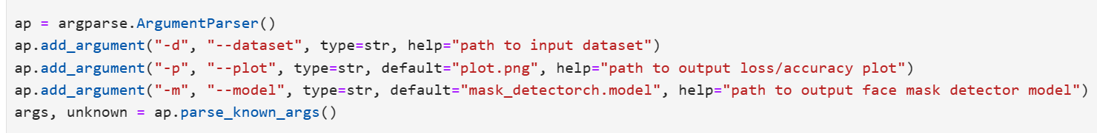

1. 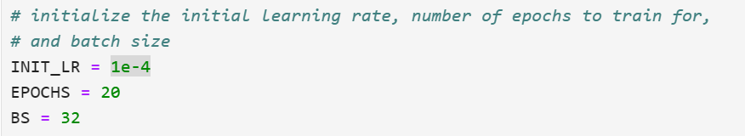Assign value for the initial learning rate = 1e-4 (1/10000) 0.0001, epoch = 20 and Batch_size = 32
2. Printing optional loading message. From imutils lib calling paths.list_images method, it basically list the image file paths from directory and its sub folders, in a nutshell it searches images from the mentioned folder and its sub folder and the file path of images returned into list and it is assigned to a variable “imagePaths”. Finally created an empty data list and labels list to append image as data and class as labels respectively.

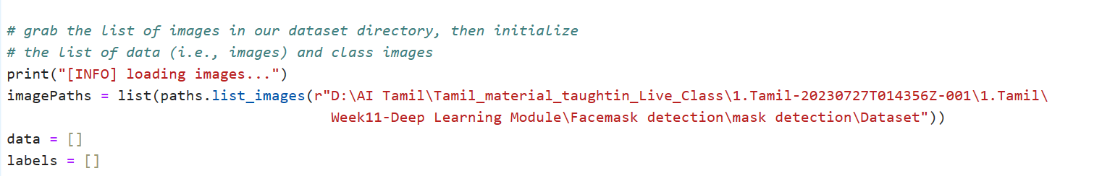

1. Using for loop iterating imagePaths (i.e., imagePaths holds “D:\AI Tamil\Tamil_material_taughtin_Live_Class\1.Tamil-20230727T014356Z-001\1.Tamil\Week11-Deep Learning Module\Facemask detection\mask detection\Dataset” including sub folder which contains images i.e., with_mask and without_mask folders. Using “split(os.path.sep)” split the file path forward “\”

Slash till location where images put up. Since [-2] used which takes before the image files in this case it takes “with_mask” and “without_mask” folder.

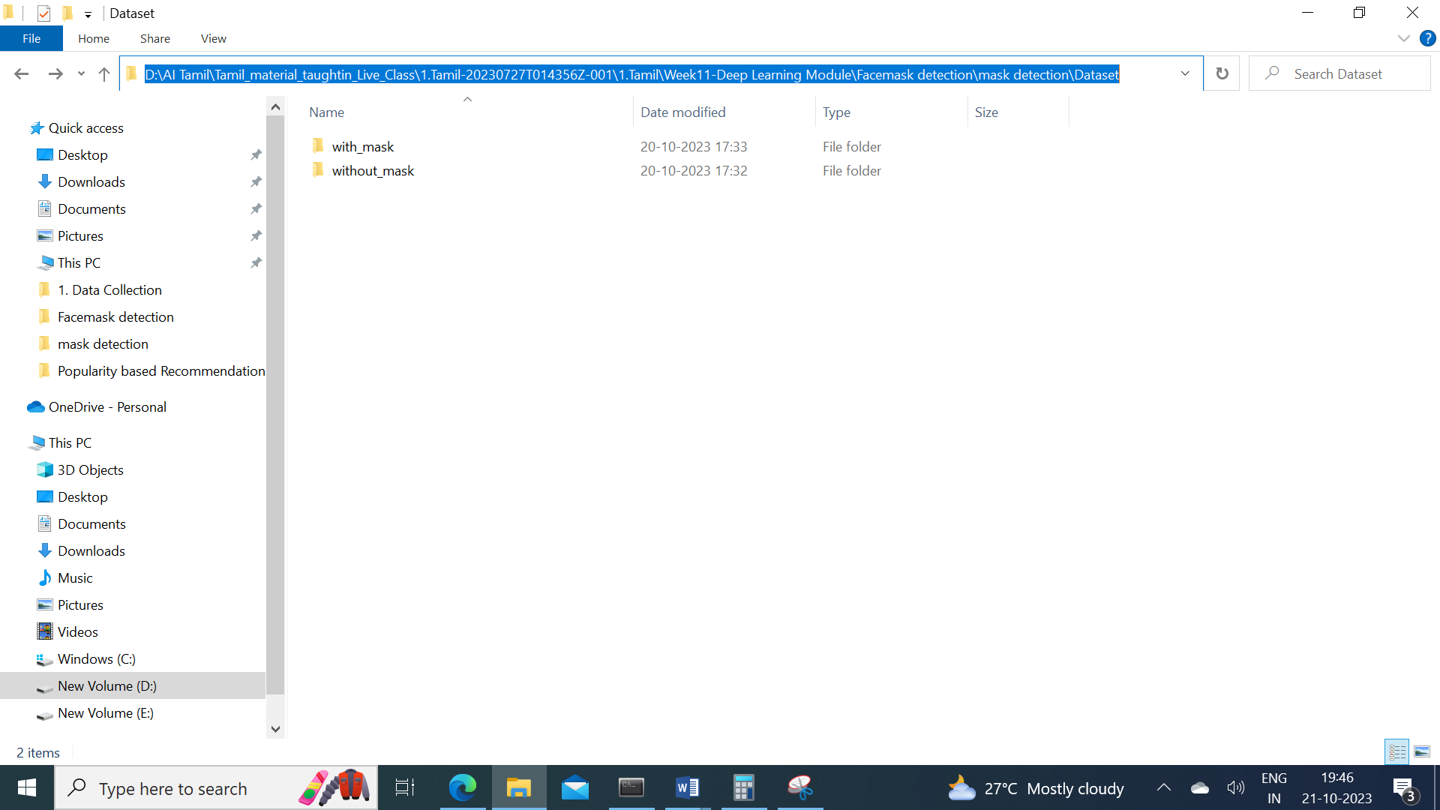

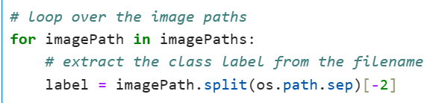

1. Using load_image method inputting the images with the pixel of 224x224 from imagePath and assign it to a variable “image”. Convert the image into array and preprocess input as per compatible to the pre-trained model and assign it to a variable “image”.

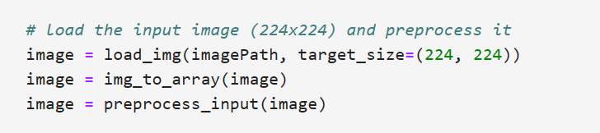

1. Finally the inputted image will be appended to the data empty list and its label (i.e., the subfolder from the dataset folder) appended to the label empty list respectively.

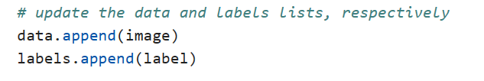

1. The data i.e., the inputted image will be converted as np.array with float 32 and assigned back to data variable to make the prediction accurate and label converted as np.array and assigned back to label respectively.

